**C PROGRAMMING PACKAGE:**

**BY 21PC25 VARUN S**

The wait for taking orders is no more! Here's a simple solution where you can order with no wait. Login to the app, select your feast through the menu, and enjoy the meal.

This program allows you to order your meal. The user should register themselves and should select the choice from the menu, along with the quantity. Once everything is done, a bill along with the total cost will be displayed.

**C PROGRAMMING PACKAGE OUTPUT:**

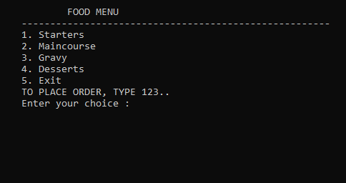

CREATING NEW ACCOUNT:

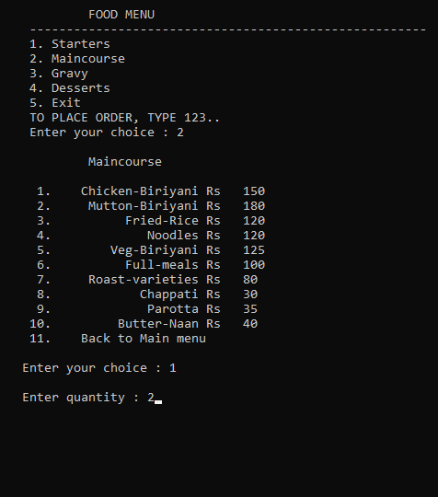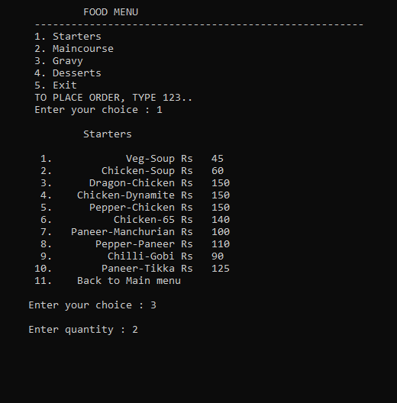

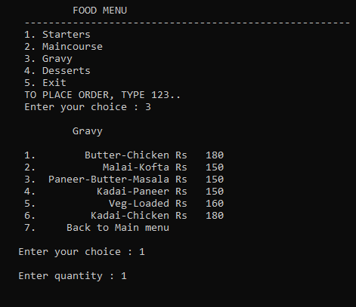

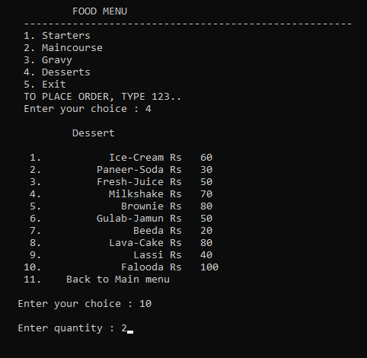

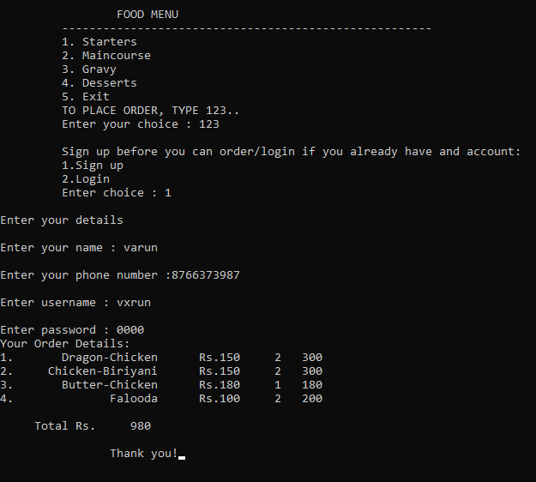

LOGGING INTO EXISTING ACCOUNT:

